**PRACTICAL – 3(3)**

**Aim:** **Create a class called Employee that includes three pieces of information as instance variables—a first name (type String), a last name (type String) and a monthly salary (double). Your class should have a constructor that initializes the three instance variables. Provide a set and a get method for each instance variable. If the monthly salary is not positive, set it to 0.0. Write a test**

**application named EmployeeTest that demonstrates class Employee’s**

**capabilities. Create two Employee objects and display each object’s yearly**

**salary. Then give each Employee a 10% raise and dis play each Employee’s**

**yearly salary again.**

**SOURCE CODE:**

import java.util.Scanner;

public class Practical_3_3 {

    public static *void* main(String *args*[]) {

        Employee x1 = new Employee();

        x1.set();

        x1.get();

        x1.raise(10);

    }

}

class Employee {

    String first_name;

    String last_name;

*double* salary;

    public *void* set() {

        Scanner sc = new Scanner(System.in);

        System.out.println("Enter Your First Name: ");

       first_name = sc.nextLine();

        System.out.println("Enter Your Last Name: ");

        last_name = sc.nextLine();

        System.out.println("Enter Your Salary: ");

        salary = sc.nextDouble();

        if (salary < 0) {

            salary = 0.0;

        }

        sc.close();

    }

    public *void* get() {

        System.out.println("\nName of Employee: " + first_name + " " + last_name);

        System.out.println("Salary of Employee: " + salary);

    }

    public *void* raise(*double* *percentage*) {

*double* Raise;

        Raise = *percentage* * salary;

        Raise /= 100;

        salary += Raise;

        System.out.println("Salary of Employee after Raise: " + salary);

        System.out.println("\n20DCE019-Yatharth Chauhan");

    }

}

**OUTPUT:**

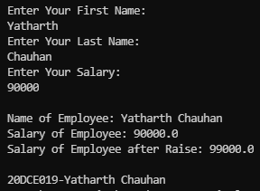

**CONCLUSION:** In this program we learnt basic concepts of making class, defining methods inside them and calling it in other classes. We learnt how to use methods of other class.